OPTISPIKE S50

Ultra-Long Range Tactical Searchlight

Features

Illuminating 5.5 km while weights 3 kg only, Optispike S50 is the ideal hand-held or vehicle mounting long range tactical searchlight. Combining state-of-the-art optical engineering and a customized solid-state light source, S50 features:

◎ Multi-mode operation: Strobe, 100% power, and 30%-100% dimming and IR mode;

◎ Adjustable beam width can be controlled by pushing the button;

◎ All the function can be controlled in one hand;

◎ A detachable battery bank with LED indicator and an external DC power port are options as power supply;

◎ Integrated with Picatinny rail cover equipped with a handle for hand-held operation or for gun/vehicle/warship mounting;

◎ Compact design with a weight including the K6 battery bank of 3 kg only;

◎ A sturdy aerospace-grade aluminum alloy housing with a HAIII military-grade hard-anodized finish that ensures rugged and reliable performance under harsh conditions and is water resistant.

Meeting all military and industry specifications, S50 is ideal for military, law enforcement, and other professional applications.

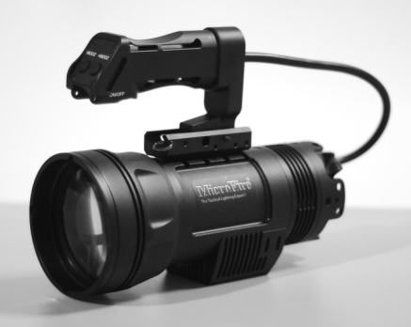

Components:

Primary components

1. 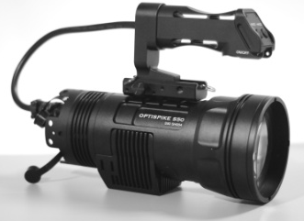 2. 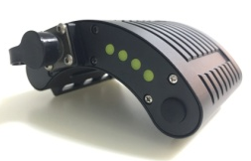 3.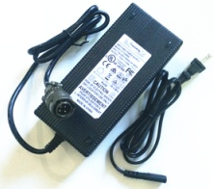
S50 K6 battery bank 100V-240V AC charger

4. 5. 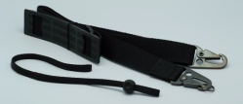 6.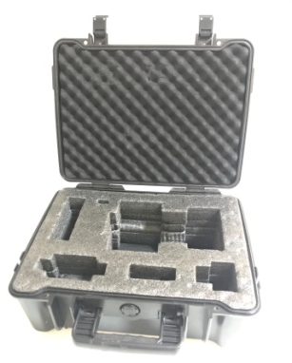
battery power cord Shoulder strap Storage case-hard case

Optional parts:

1. 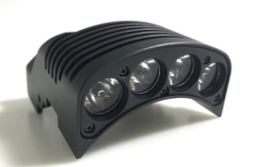 2. 3. 4.
Auxiliary IR module DC vehicle charger Amber filter 12 V - 28 VDC vehicle adapter

Operation instructions:
1. Connect K6 battery bank:
  - Connect the F1 power cord to S50 via the four - pin connector
"DC 12V";
  - Connect the K6 rechargeable battery bank at the other end.

It shows S50 is connected with K6 battery bank.

2. Power on/off and adjust the brightness modes:
- Connect the handle controller to S50 via
the six-pin connector "Controller";

Six-pin remote controller connector socket

- Press the ON/OFF button in the bottom side of the handle controller, the default mode is 100% power with a beam throw up to 5,500 m;
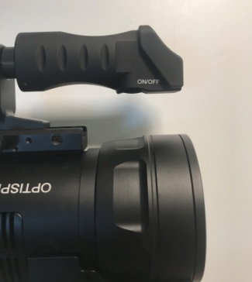

ON/OFF button

- ON/OFF button can also switch the modes.
From 100% power to 30% power:
Press and hold it for more than 3 seconds, the beam intensity will drop to 30% of its initial value

From 30% power to 100% power:
Press and hold the button, S50 will slowly come back up to 100% power from 30% power. There will have more than 20 modes during process. Release the button to lock the brightness mode you need.

Strobe activation:
When S50 is off, press and then release the ON/OFF button after 1.5 seconds, strobe will be activated.

3. Beam divergence adjustment:

There are two smaller buttons on the upper side of handle controller which are used to adjust the beam divergence.

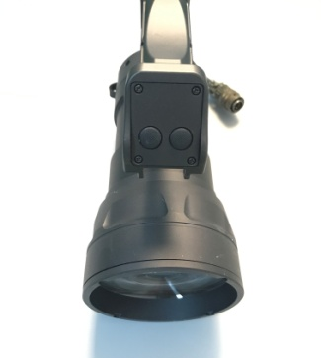
FLOOD
SPOT

Press and hold the SPOT button, the beam divergence will become smaller till 0.8°
Press and hold the FLOOD button, the beam divergence will become bigger till 15°

4. Switch white beam and IR:
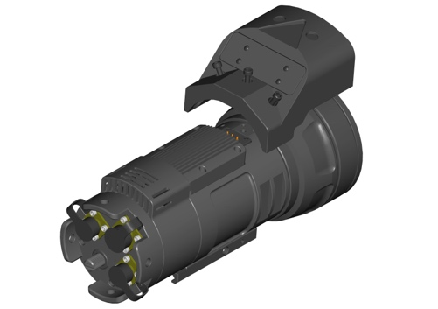
4.1 The auxiliary IR module can be screwed on S50 easily.
Three screws to fix
the IR module

4.2 When the ON/OFF button is ON, you can switch the white beam and IR beam by revolving the knob on the rear. When the white dot on the knob is pointing to "W", S50 will work in white beam. Otherwise when the white dot is pointing to "IR", S50 will work in Infrared beam.

IR/White knob

5. Switch the beam divergence of IR:
There are four IR LED in the IR module, the centered two IR LED puts out a narrow beam of 5° and those on edges put out a wide beam of 60°.

All IR LEDs are on when switch on (shown in pic A)
Push the ON/OFF button, the narrow IR beam is on(shown in pic B).
Push the ON/OFF button again, the wide IR beam is on(shown in pic C).

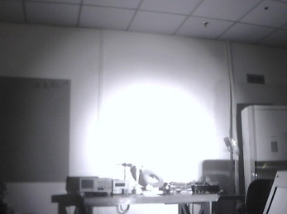
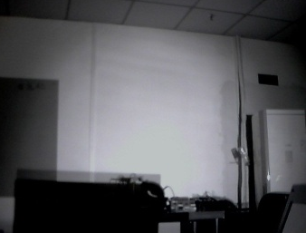
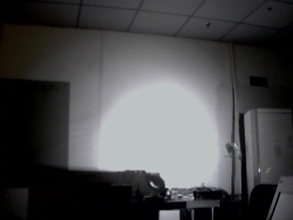
A B C

6. Charge the K6 battery bank:
Check button
LED indicator

6.1 Driven by K6 rechargeable battery bank, S50 can run for 75 mins at 100% brightness and the longest runtime is 4.5 hours.

6.2 By pushing the check button, LED indicators can signify the battery power status with the number of LED on.
4 LEDs on: full power
3 LEDs on: 75% power left
2 LEDs on: 50% power left
1 LED on: 25% power left

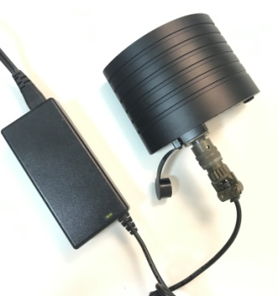
6.3 Please charge K6 battery bank with the D6 wall charger regularly.
- Insert the power plug of the D6 wall charger into a wall socket. The LED indicator light on the charger should turn GREEN. If not, check the connection.
- Remove the rubber cap, and then insert the DC connector into the connector located on the K6 battery bank. The LED indicator light on the charger should turn RED which means the battery bank is being charged.

- After 2 hours, the battery power should reach 95% of its capacity and the LED indicator light on the charger will once again turn back to GREEN. Please leave the battery pack charging for one more hour to ensure a full charge.

6.4 Remarks:
    - Due to the specialty of Lithium-ion rechargeable battery, please recharge the battery bank before you storage it. If the S50 has not been used for a long time, please discharge and recharge it per THREE MONTHS as battery maintenance. It may need to be recharged before it can be used again as the battery bank may have drained out.

    - When not in use, S50 should be stored away at temperatures below -30℃ or permanent damage could be done to the batteries.

Safety Warnings:

1. Do not look at S50 directly when it is on. Exposure of the eye to either the direct searchlight beam or a beam reflected from a flat mirror-like surface can cause permanent eye injury to the unprotected eye. Follow the same precaution even when S50 is working on Infrared mode.

Nominal Ocular Hazard Distance (NOHD), Visible Light: 10 meters
NOHD, Infrared Light: 30 meters for exposures greater than 10 seconds

2. Do not attempt to disassemble, repair, or alter the searchlight or any part/accessory thereof by yourself. S50 is a very high precision product and all defective parts or products should be sent to your local MicroFire dealer for repair or replacement.
3. Always disconnect S50 from power cord when not in use, when placed in storage or when being transported to prevent accidental activation.

4. Do not operate light in an explosive environment.

5. Keep this searchlight out of reach of children.

Warranty and Terms:
- MicroFire Limited Warranty:
MicroFire products are warranted for quality and different parts may be covered by a different warranty period:
a) S50 searchlight: 24 months
b) Rechargeable battery bank: 180 days
c) AC charger DC charger: 2 years
d) Other searchlight accessories excluding the parts above: 2 years
Products shall be free of defects in materials and workmanship under normal use and that MicroFire Company Limited. shall, at its option, repair or replace any defective product upon the prepaid return of the product to its factory.
The warranty only applies to defects in materials and workmanship and not to damage incurred in shipping or handling, damage due to abuse, misuse, alteration or improper application of the equipment. Damage incurred in return shipping and handling due to improper packaging is not covered.
In order to be eligible for coverage under the warranty, the equipment must have the original MicroFire Company Limited. label with a legible serial number attached. Removal of any portion of the factory-affixed labels on any product will result in the voiding of any written or implied warranty.

2. MicroFire rights and liabilities:
a) As a non-retail original manufacturer, MicroFire does not accept any direct Warranty claims from individual customers.
b) Any complaints of the buyer shall only be considered if received from the distributors / dealers of MicroFire, and buyer's warranty claims are limited to rectification or replacement at our choice. Liability for consequential damages is excluded.
c) MicroFire’s contractual or tortuous liability for damages of any kind is excluded.

MicroFire Company Limited
Add:5th floor, No.25, Keji North No.2 Rd
Shenzhen,518057
Tel:86 755 26994678
Email: info@microfire-system.com

